Employee Segmentation Report

1. Objective
The aim of this project is to divide the employees of a company into groups (segments) of similar employees and to find which groups are more likely to leave. We used K-Means and Hierarchical clustering to make the segments, and PCA to reduce the features and to plot the groups. We then studied the high-risk clusters, the department-level segments, the performance groups and the retention risk groups.

2. Data and features
We used the IBM HR employee attrition dataset with 1,470 employees and 35 columns. There are no missing values. A total of 237 employees have left, so the overall attrition rate is 16.1%.
We used 20 features for clustering. Besides the original work-related columns (age, job level, monthly income, total working years, years at company, overtime, travel and so on) we created four new features:
- IncomeToLevel = monthly income divided by job level
- TenureRatio = years at company divided by (total working years + 1)
- PromotionGap = years since last promotion divided by (years at company + 1)
- SatisfactionIndex = average of environment, job, relationship satisfaction and work-life balance
Attrition, PerformanceRating and PercentSalaryHike were not used for clustering. We kept them aside so that we could use them later to check the segments.

3. Method
- All 20 features were scaled with StandardScaler.
- PCA was applied and 13 components were kept. They explain 92.7% of the variance (see the PCA Summary).
- K-Means was run for k = 2 to 9 on the PCA data and k was chosen using the silhouette score.
- Hierarchical clustering was run with three linkage methods (Ward, average and complete) and compared.
- K-Means and Hierarchical (Ward) results were compared and the K-Means segments were used for the rest of the analysis.

3.1 Choosing the number of segments
Two groups have the highest silhouette score (0.191), but we wanted a more detailed segmentation than just two or three groups. So we looked only at k = 4 to 6 and chose the best silhouette among them. This was k = 4.
k | Silhouette | Davies-Bouldin | Calinski-Harabasz
2 | 0.191 | 2.008 | 328.3
3 | 0.135 | 2.201 | 251.4
4 (chosen) | 0.120 | 2.143 | 219.9
5 | 0.113 | 2.202 | 196.4
6 | 0.112 | 2.234 | 177.2

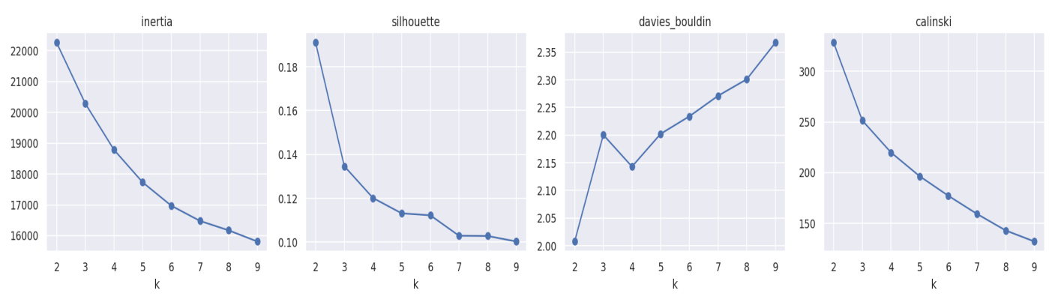
Figure 1: Scores for different values of k

3.2 Hierarchical clustering
Linkage | Cophenetic corr. | Silhouette | Davies-Bouldin | Smallest cluster | ARI vs K-Means
Ward | 0.588 | 0.113 | 2.180 | 92 | 0.448
Average | 0.655 | 0.180 | 1.355 | 1 | 0.176
Complete | 0.563 | 0.114 | 2.184 | 120 | 0.417

Average linkage has the best scores, but its smallest cluster has only 1 employee, so it is not useful for segmentation. We used Ward linkage because it gives clusters of reasonable size and is the closest to K-Means.

3.3 K-Means vs Ward
Measure | K-Means | Hierarchical (Ward)
Silhouette | 0.121 | 0.113
Davies-Bouldin | 2.141 | 2.180
Calinski-Harabasz | 219.9 | 187.1

K-Means is slightly better on all three measures. The agreement between the two methods is moderate (Adjusted Rand Index = 0.448), so they do not give exactly the same groups. The scores are low in general (silhouette about 0.12), which means the segments overlap.
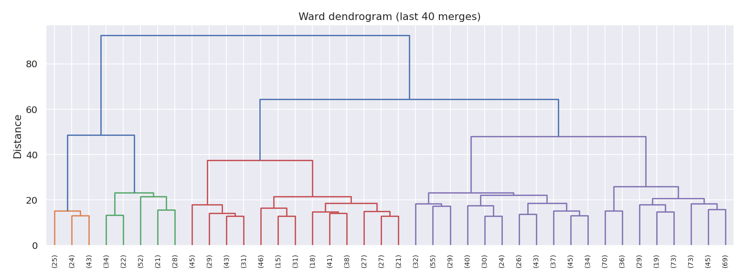
Figure 2: Dendrogram of the Ward hierarchical clustering

4. Segment profiles
K-Means gave four segments. We named them by looking at the income and the tenure of each group.
Segment | Staff | Age | Income | Job level | Tenure | Yrs since promo | Overtime | Attrition
Entry-Level Early Career | 554 | 30.6 | 3,323 | 1.26 | 3.6 | 0.7 | 28.2% | 23.5%
Stable Mid-Career | 392 | 36.1 | 6,011 | 2.07 | 10.3 | 3.8 | 24.2% | 11.2%
Experienced Newcomers | 369 | 43.2 | 8,015 | 2.42 | 3.5 | 0.7 | 32.8% | 13.6%
Senior Veterans | 155 | 46.5 | 15,514 | 4.06 | 19.2 | 6.9 | 28.4% | 8.4%

- Entry-Level Early Career employees are young, with low income and a low job level, and about 3.6 years in the company. They have the highest attrition (23.5%).
- Stable Mid-Career employees have about 10 years in the company and medium income. They have the lowest overtime (24.2%) and a low attrition of 11.2%.
- Experienced Newcomers are older (43 years) and have a good income and job level, but only about 3.5 years in the company, so they have joined recently with earlier experience. They have the highest overtime (32.8%) and an attrition of 13.6%.
- Senior Veterans are the smallest group with the highest income and job level and the longest tenure (19.2 years). Their attrition is the lowest (8.4%).
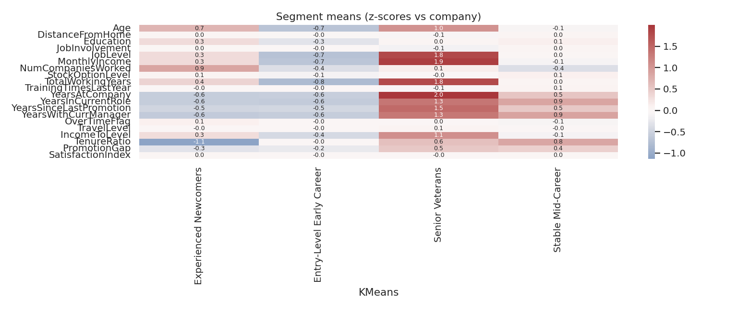
Figure 3: Segment averages compared with the company average (z-scores)
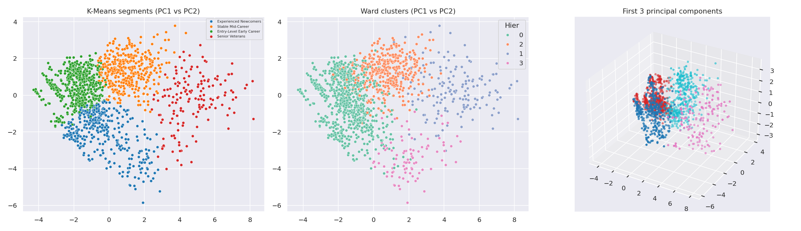
Figure 4: Employee segments in PCA space

5. High-risk employee clusters
The company attrition is 16.1%. Entry-Level Early Career is the only segment clearly above this (23.5%), and it holds 130 of the 237 leavers. Experienced Newcomers (13.6%), Stable Mid-Career (11.2%) and Senior Veterans (8.4%) are all below the company average.
The Experienced Newcomers segment is worth watching even though it is below average. These employees have the highest overtime and have been in the company only a short time.

6. Department-level workforce segments
Department | Staff | Attrition | Entry-Level | Newcomers | Stable Mid | Sr. Veterans
Human Resources | 63 | 19.0% | 44.4% | 23.8% | 17.5% | 14.3%
Research & Development | 961 | 13.8% | 39.4% | 25.2% | 25.0% | 10.4%
Sales | 446 | 20.6% | 33.0% | 25.1% | 31.6% | 10.3%

Sales (20.6%) and HR (19.0%) have higher attrition than R&D (13.8%). Entry-Level Early Career is the biggest segment in HR and R&D, while in Sales it is almost equal to Stable Mid-Career (33.0% and 31.6%). HR has only 63 employees, so its numbers are not very stable.

6.1 Department-specific segments
We also ran a separate K-Means with 3 groups inside each department. The groups with a high attrition were:
Department | Group size | Attrition | Avg income | Tenure (yrs) | Overtime
Sales | 234 | 27.8% | 5,137 | 3.2 | 31.2%
Human Resources | 50 | 22.0% | 3,981 | 5.0 | 26.0%
Research & Development | 592 | 17.2% | 3,718 | 4.0 | 28.4%

The highest attrition among all of them is in a Sales group of 234 employees with a low income, short tenure of about 3 years and 31.2% overtime. In every department the group with the high attrition is the one with a low income and a short tenure. The senior, high-income groups have less attrition (for example 5.2% in R&D and 14.3% in Sales). The small HR group of 6 people has 0% attrition, but it is too small to say anything.
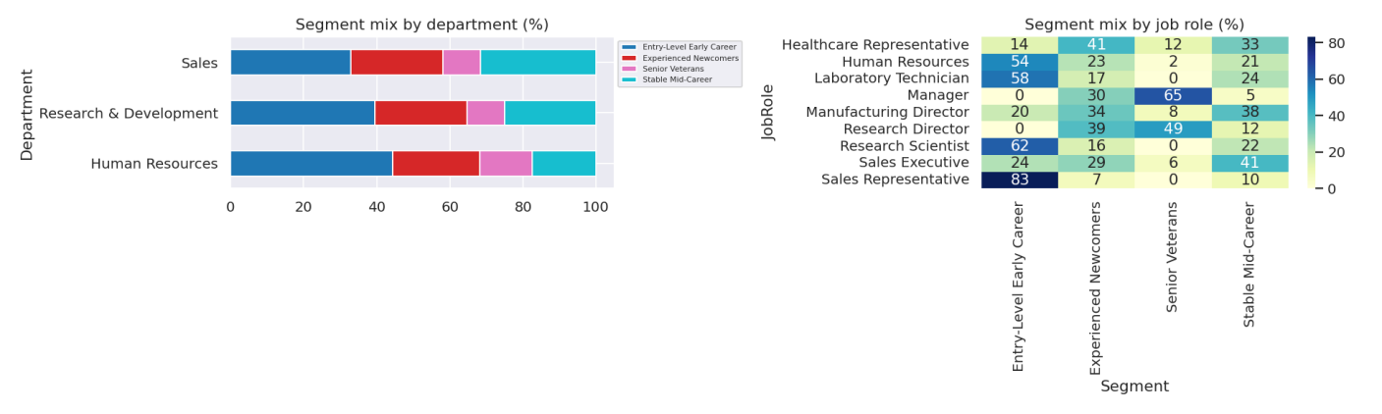
Figure 5: Segment mix by department and by job role

7. Performance groups
We made a performance and engagement index by averaging the z-scores of PerformanceRating, JobInvolvement, PercentSalaryHike and TrainingTimesLastYear. Then we split the employees into three equal groups of 490.
Performance group | Employees | Attrition | Avg income | Avg rating | Avg involvement
Low performers | 490 | 21.8% | 6,676 | 3.00 | 2.29
Core performers | 490 | 13.3% | 6,570 | 3.00 | 2.91
High performers | 490 | 13.3% | 6,263 | 3.46 | 2.99

Low performers leave the most (21.8%). Core and High performers both have 13.3%. There are 65 High performers who left (13.3% of that group). The three performance groups are spread almost evenly in every segment (roughly 28% to 36% each), so performance does not depend on the segment.

8. Retention risk groups
For the retention risk groups we used a logistic regression only as a risk scorer. Every employee got a risk score from a 5-fold cross-validation, so nobody was scored by a model that had seen his or her own result. The model used the same 20 features plus Department, JobRole, MaritalStatus and Gender. The out-of-fold ROC-AUC of the score is 0.839. The top 20% of scores were marked High, the next 30% Medium and the rest Low.
Risk tier | Employees | Leavers | Attrition
High | 294 | 154 | 52.4%
Medium | 441 | 53 | 12.0%
Low | 735 | 30 | 4.1%

The High tier has only 20% of the employees but holds 65.0% of all leavers, and its attrition rate (52.4%) is about 13 times that of the Low tier (4.1%).
Segment | High | Medium | Low
Entry-Level Early Career | 29.4% | 36.3% | 34.3%
Experienced Newcomers | 18.7% | 29.3% | 52.0%
Stable Mid-Career | 11.2% | 26.8% | 62.0%
Senior Veterans | 11.6% | 17.4% | 71.0%

Entry-Level Early Career has the biggest share of employees in the High tier (29.4%), and Senior Veterans have the biggest share in the Low tier (71.0%). This agrees with the segment attrition rates.
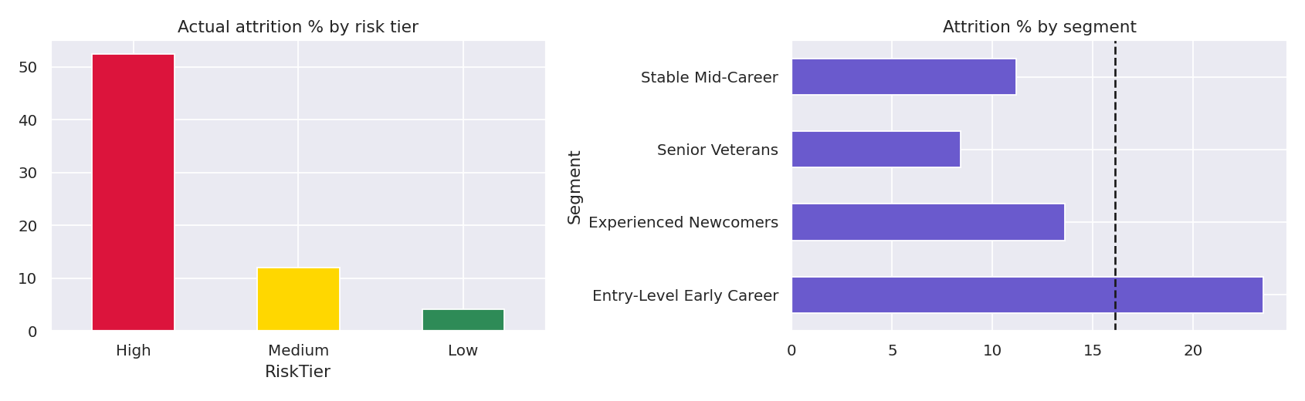
Figure 6: Retention risk groups

9. Suggestions for HR
These are our own suggestions based on the results. The data shows which groups leave more but it does not prove the reasons.
- Focus the retention efforts on the Entry-Level Early Career segment, which has the highest attrition, and on the High risk tier, which holds 65% of the leavers.
- Check pay and career growth for low-income, short-tenure employees, especially in Sales.
- Look at the workload of Experienced Newcomers, as they have the highest overtime.
- Look at low performers as a group that needs support, because they leave more than the others.
- Use the risk score together with the segments, and repeat the analysis every year.

10. Limitations
- The silhouette scores are low (about 0.12), so the segments overlap and should be treated as broad groups.
- K-Means and Ward agree only moderately (ARI 0.448), so the segment borders depend on the method.
- We chose k = 4 from a limited range (4 to 6) because we wanted a more detailed segmentation. Two groups would have a higher silhouette score.
- The dataset is a sample HR dataset, and the results may be different for another company.
- The analysis shows relations, not causes.

11. Conclusion
We divided the 1,470 employees into four segments using PCA and K-Means. The Entry-Level Early Career segment is the high-risk cluster with 23.5% attrition, and the Senior Veterans segment is the most stable with 8.4%. Sales and HR have higher attrition than R&D, low performers leave more than the other groups, and the risk score separates the employees well (the High tier holds 65% of the leavers).

